Restaurants Analytics

Detailed BRD

**Produced for**

**Abhay Kumar**

**&**

**Amit Kumar**

**Version 1.1**

Contents

1 Document Information 4

2 Cisco Architecture Focus Partner Tool – Skillset Overview 5

2.1 Application Objective: 5

2.2 Project Goals 5

3 Modules in Focus Partner List - Skillset 6

The modules of the application are as follows: 6

3.1 PARTNER DASHBOARD: 7

3.2 GTMu DASHBOARD: 9

3.3 PARTNER PROFILE: 10

3.4 LANGUAGE SUPPORT - ENGLISH: 13

4 Admin Modules 14

4.1 USER MANAGEMENT: 14

4.2 ADMIN ROLES: 16

4.3 USER METRICS: 17

4.4 DATA MAINTENANCE: 17

5 Business Process: 18

6 About the Business Requirement Document: 19

**Document History**

*{Each person who updates this document should enter information for each version of the document. Version 1.0 is considered the official version that has been signed off by all stakeholders.}*

|  |  |  |  |  |
| --- | --- | --- | --- | --- |
| **Rev. #** | **Date** | **Author** | **Section #** | **What Changed?** |
| 0.1 | 06 Aug 2014 | Padmaja Ravikumar |  | Incorporating initial requirements |
| 0.2 | 07 Aug 2014 | Padmaja Ravikumar |  | Incorporating changes from first review |
| 0.3 | 08th Aug 2014 | Padmaja Ravikumar |  | Incorporating changes from second review with business stakeholder |
| 0.4 | 21th Aug 2014 | Padmaja Ravikumar |  | Incorporating changes from review with business stakeholder |
| 0.5 | 09th Sep 2014 | Padmaja Ravikumar |  | Final BRD after the review and scope |
| 0.6 | 19th Sep 2014 | Padmaja Ravikumar |  | After discussing with IT |

**Document Reviewers**

*{Please list all document reviewers. This may include IT theater analysts and other business stakeholders..}*

|  |  |
| --- | --- |
| **Name** | **Role** |
| Ting Miao | Project Manager, APJC IT Business Solutions |
|  |  |
|  |  |

**Business Document Approvers**

*{Please list all must include all Business Process Owners for each theater. The business approvers are approving sections 3 and 4.}*

|  |  |  |
| --- | --- | --- |
| **Name** | **Role** | **Date Approved** |
| Deborah Wong Chin Nee | SALES BUSINESS DEV MANAGER | Verbal Approval – 9th Sep 2014 |
| Adam Britten | MANAGER SALES BUSINESS DEVELOPMENT |  |
|  |  |  |

**IT Document Approvers**

*{Please list all required IT approvers. This must include all PMs of impacted applications. The IT approvers are approving sections 3, 4, 5, and 6}*

|  |  |  |
| --- | --- | --- |
| **Name** | **Role** | **Date Approved** |
|  |  |  |
|  |  |  |
|  |  |  |
|  |  |  |
|  |  |  |

# Document Information

The main purpose of this document is to document the requirements of Architecture Focus Partner Tool - Skillset in a structured manner.

This document will be used to

* Design the overall data and application architecture
* Create an IT functional design that will fulfill the must-have features.

## Business Objective:

The business focuses to leverage the big data analytics to better understand the consumers of the food industry and to make the food providers (Restaurants) more efficient and productive. We plan to perform rigorous market analysis on the entire user and market data possible over a period of time by providing the users with a web and mobile interface for making reservations to the restaurants. We will be providing the consumers with incentives for filling out their food preferences and feedback which will be used by our analytics algorithm to derive related conclusions to drive the business growth.

# Modules in Focus Partner List - Skillset

.

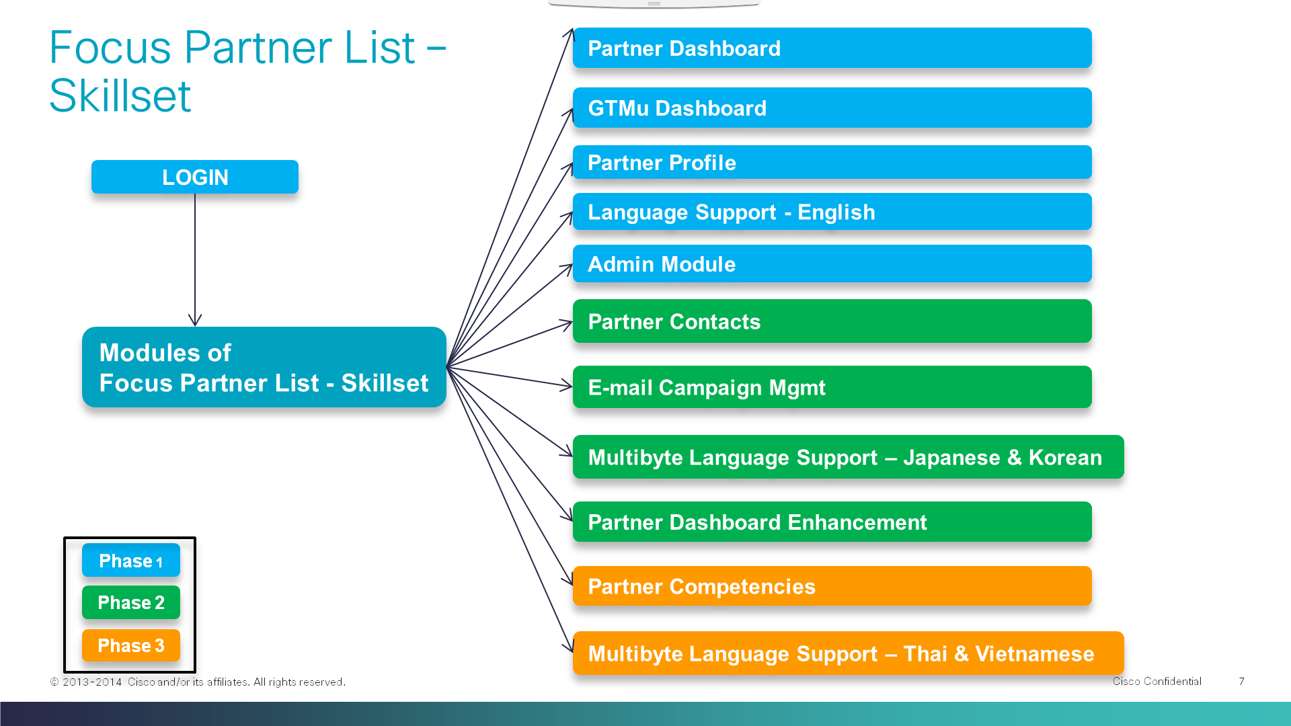

## The modules of the application are as follows:

* Application Modules
* Partner Dashboard
* GTMu Dashboard
* Partner Profile
* Language Support - English
* Admin Module
* User Management
* Partner Contacts
* E-mail Campaign Mgmt
* Multibyte Language Support – Japanese & Korean
* Partner Dashboard Enhancement
* Partner Competencies
* Multibyte Language Support – Thai & Vietnamese

**Phase 1**

**Phase 2**

**Phase 3**

The color identification is as per the above definition of Phases. In this BRD we are only capturing Phase 1 Requirements. Phase 2 & 3 requirements will be captured separately in a different Business Requirement Document.

## PARTNER DASHBOARD:

Partner Dashboard is the reporting module of the tool. The business wants this functionality to be dynamic, with data filters that will provide meaningful intelligence to stakeholders.

**FILTER :** Filter attributes will be Theatre & Country.

**ACCESS:** The access of this dashboard should be restricted to the user’s profile of the Theatre and Country. This dashboard should be refreshed with the logged in users Theatre and country.

Partner Dashboard mainly will have 3 types of analysis.

* Geographical Analysis
* Strategic Analysis
* Qualification Analysis

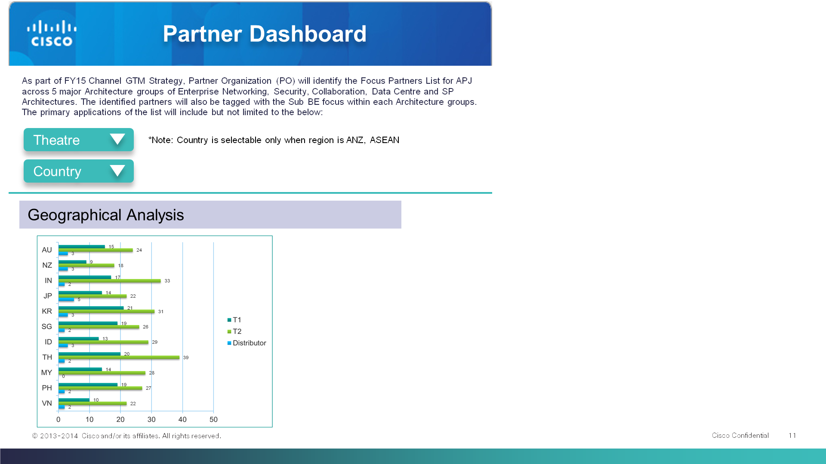

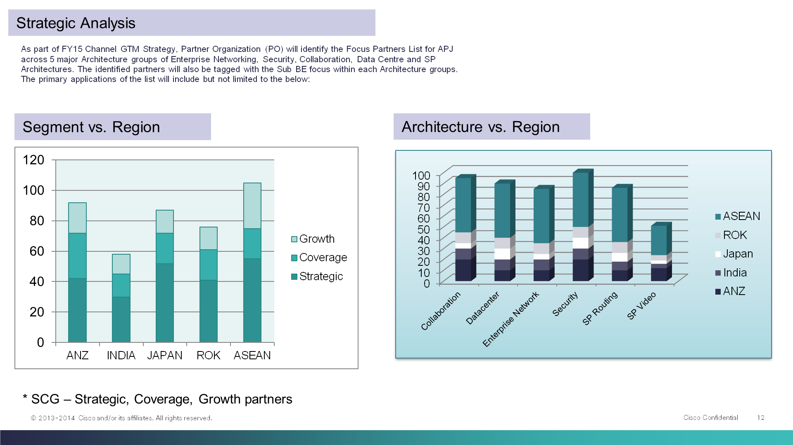

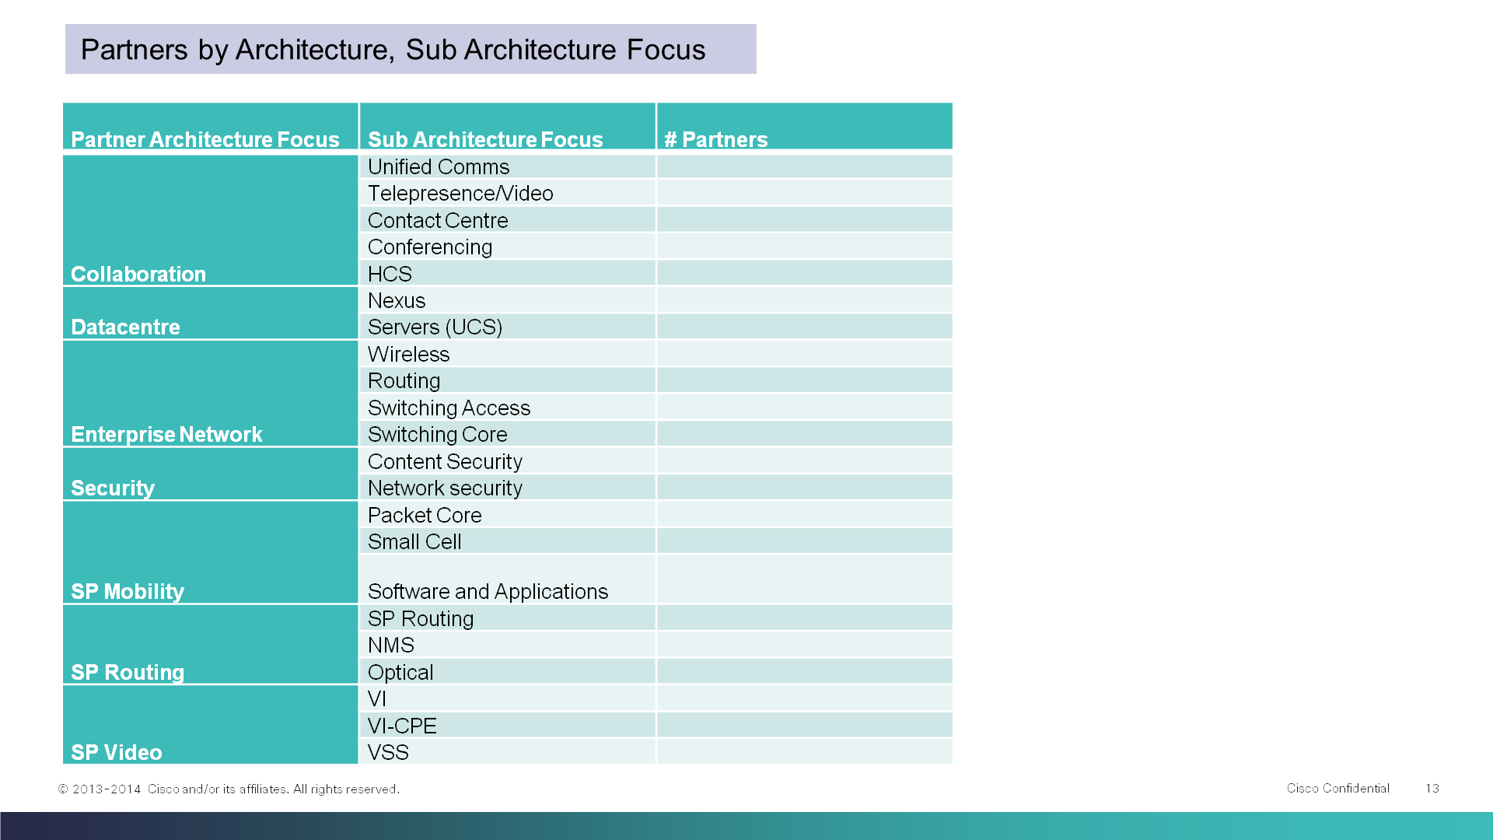

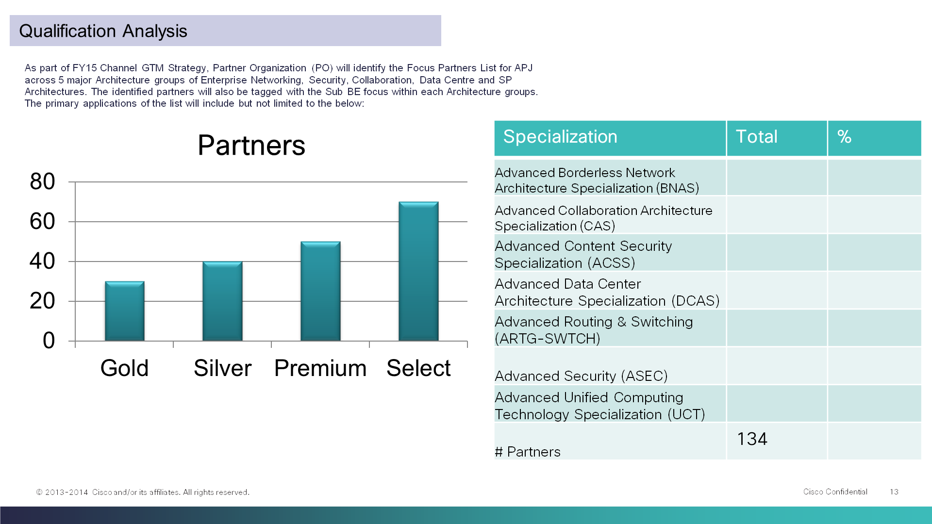

## GTMu DASHBOARD:

GTMu is a node description of the Sales Hierarchy. It is actually a combination of Segment and the Vertical solution of the accounts.

A dedicated dashboard should be designed for viewing the metrics of the GTMu dashboard.

Based on the booking revenue GTMu will be derived from the GTMu mapping. Currently APJ business team will provide the booking revenue GTMu mapping for the focal partners. Revenue GTMu mapping, Architecture will be refreshed quarterly as of now and will consider the frequency later on depending on the business requirement.

For each of the partners top 5 GTMus will be considered for displaying in the dashboard.

* Upload the raw data to the database and derive the top 5 GTMus systematically

FILTER : Filter attributes will be Theatre & Country.

ACCESS: The access for this dashboard should be restricted to the user’s profile - Theatre and Country. This dashboard should be refreshed with the logged in users Theatre and country.

REPORTS:

1. Top 5 Focus Partners for all the available GTMu

When the user clicks on the Partner name top 5 Architecture should be displayed.

2. Top 5 Architecture Vs. Top 5 GTMu

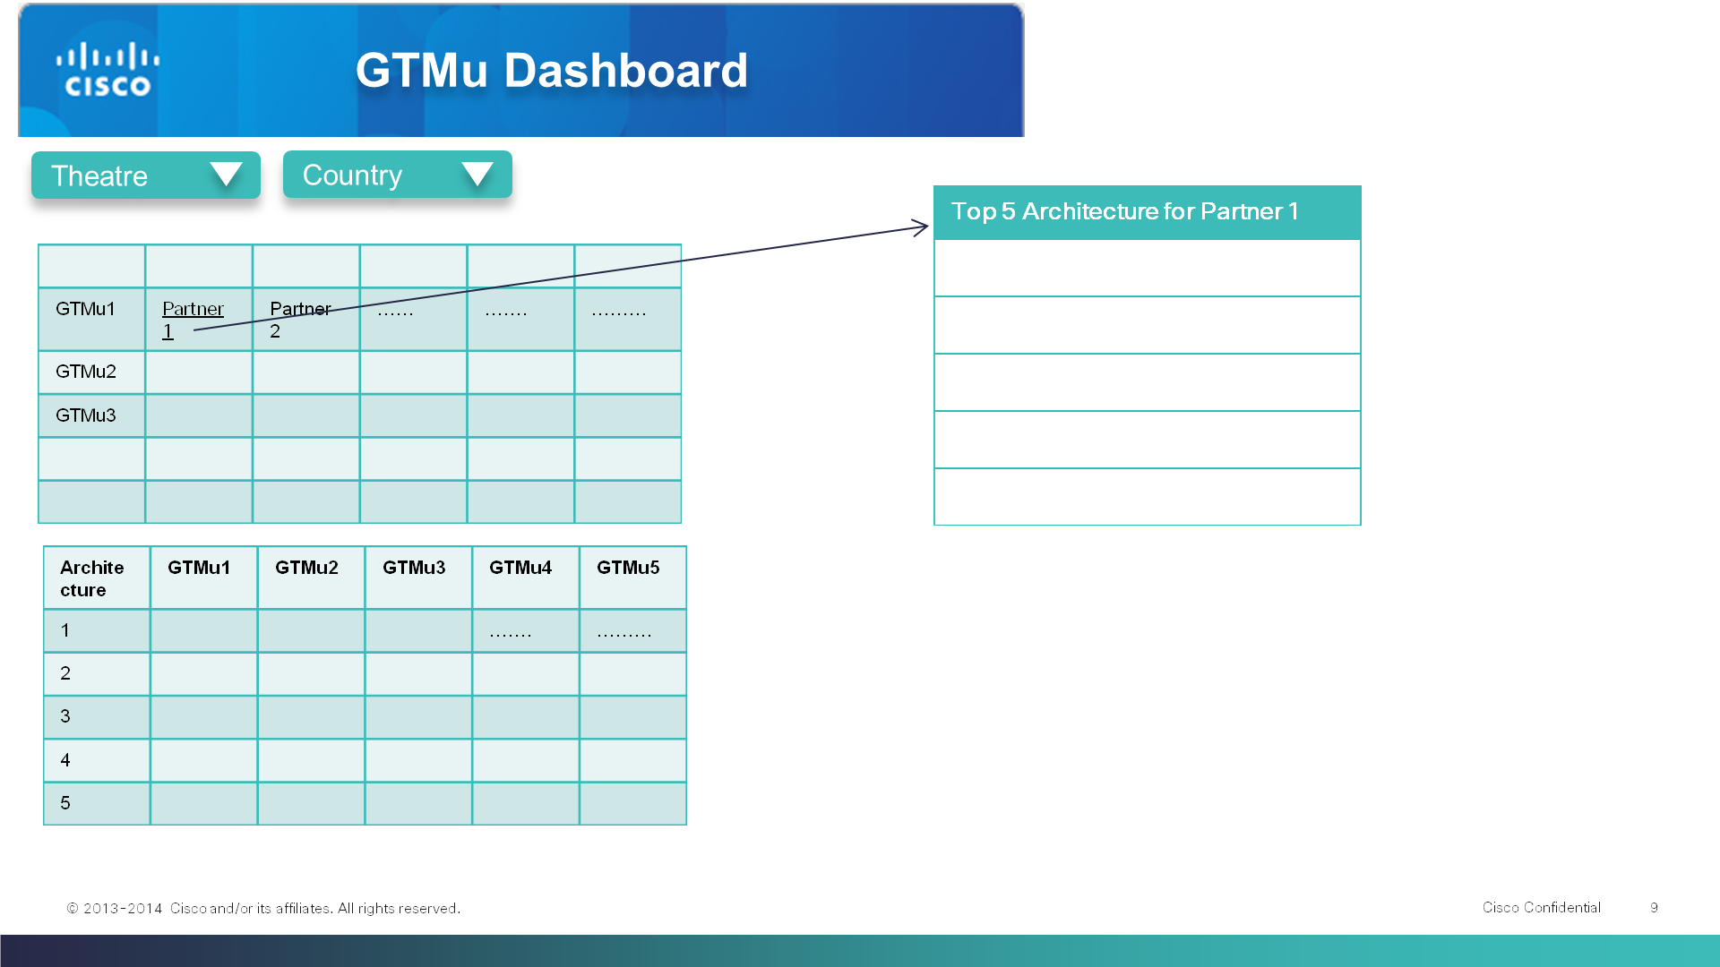

## PARTNER PROFILE:

Partner Profile is mainly used to identify the Architecture Focus Partner List and also the Profile of each of the Partner contacts. As per the requirement we have identified the following attributes to be maintained as part of Partner Profile module.

* **PDB Analytics Attributes**
* BE id
* Partner Name ( This is usually Global name of the company )
* Be Geo Id
* BE GEO NAME
* Super_Region
* Geo Cd
* Sub_Region
* Country
* ISO Country Code
* HQ_SITE_ID
* HQ_ADDRESS
* Site City
* Site State
* HQ SITE ZIP
* Qualification Code (Certification)
* Qual Status Cd
* Qualification(Specialization)
* Effective Date(MM/DD/YYYY)
* Expiration Date(MM/DD/YYYY)
* Expiration Month
* Partner Type
* Partner Subtype
* Specialization Expiration Date (Check with IT)

**Manual / Derivation Attributes**

* Partner Tier (1-Tier or 2-Tier)
* Segmentation
* Partner Architecture Focus
* Sub Architecture Focus
* Comment ( Feedback on the Partner Profile information ) – EDITABLE
* Booking GTMU ( Top 5 GTMus )
* Booking Architecture

**System Attributes**

* Partner Status ( Activate / Deactivate )

*NOTE – The above attributes are from PDB Analytics. We are still working on the GAP analysis between SFDC Partner report and PDB Analytics to identify the correct set of the Partner Profile Attributes.

ACCESS: The access of this dashboard should be restricted to the user’s profile of the Theatre and Country. This dashboard should be refreshed with the logged in users Theatre and country.

g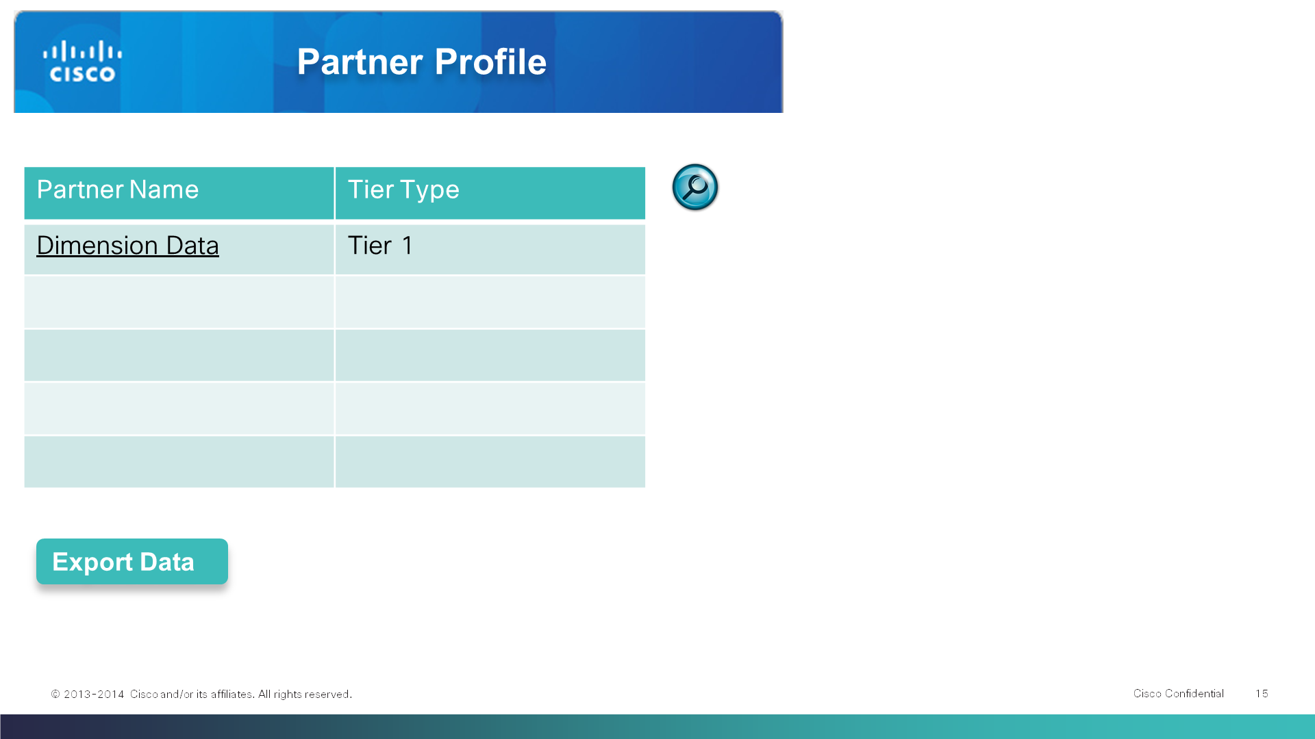

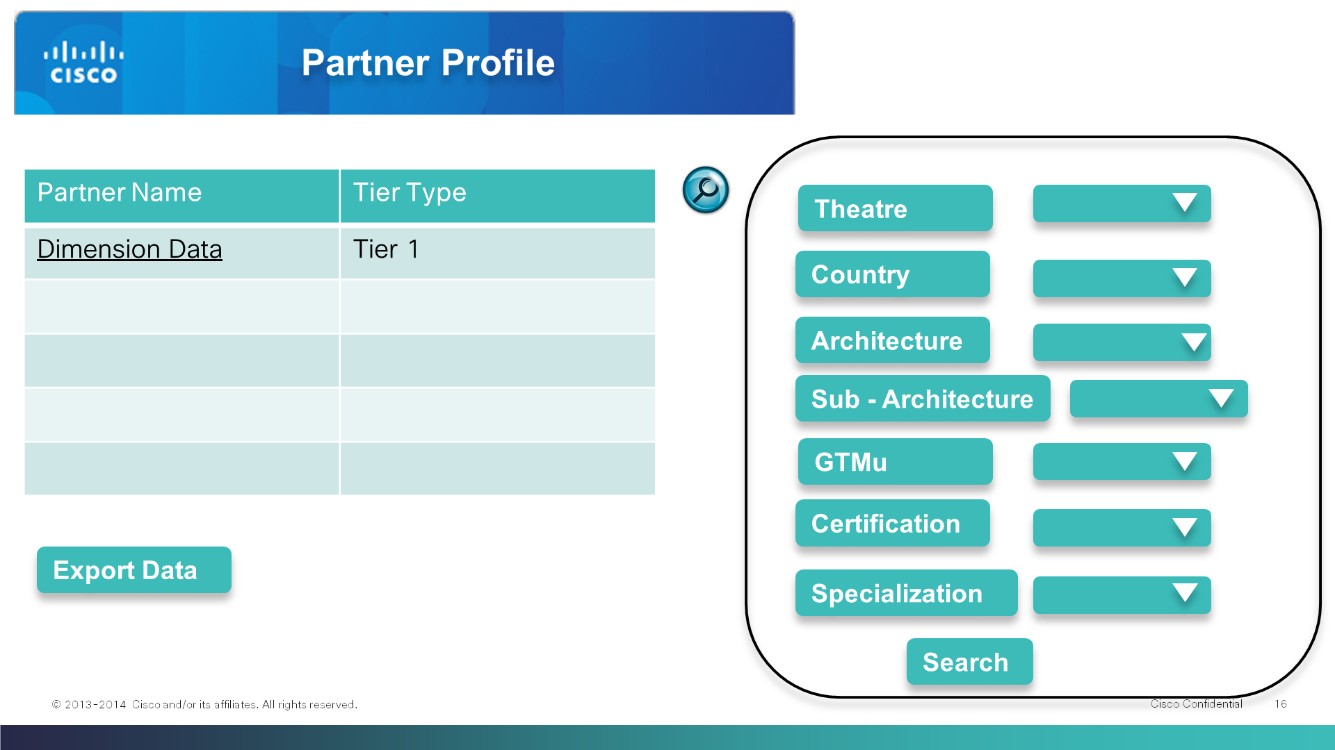

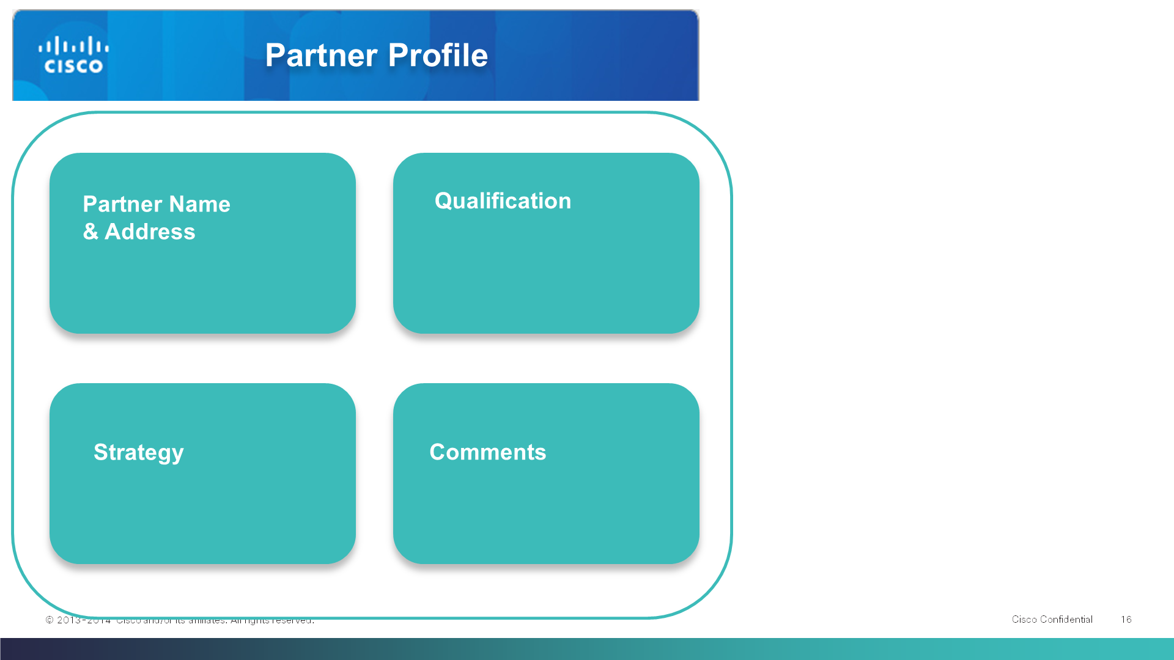

COMMENTS: If the logged in users identify any modification in the Partner Name or Partner Company Address or Partner Contact details they can alert the Admin with the modified / changed data.

An email is sent to the Super Admin with the feedback / Comment from the users.

Email Content

System email ID – mail will be sent out to super admin.

User ID

Region

Theatre

Country

Role

Comments:

As per our discussion we agreed that the PDB is considered as SSOT (Single Source Of Truth) and the modification requests will be sent out to PDB team by the super admin. We will only keep the latest information in our database and no historical data is maintained. Even in the comments attribute only the latest modification request will be shown.

EXPORT:

The user should be able to download the Partner profile data when they click on Export button.

## LANGUAGE SUPPORT - ENGLISH:

This application will require multi-byte language support. As a part of initial requirement, the application will implement support in English.

Additional language support is to be supported in Phase II and Phase III which includes.:

- Japanese

- Korean

- Thai

- Vietnamese

# Admin Modules

## 4.1 USER MANAGEMENT:

The application is only accessible by the Cisco internal team through the authentication via CEC ID.

The generic rule is that the Partner Profile and Partner Contacts data view should be restricted to the Sub_Region and the Country that the user is responsible for. Users are required to apply for their access rights; the Super Admin will approve or reject the access for the users based on their role relevance to the tool.

The primary users that will gain approval to the tool include but not limited to below:

**Theatre/ Country Partner Organization**

• Partner Organization leads (MPOs)

• Partner Account Managers (PAMs)

• Distribution Partner Account Managers (DPAMs)

• Channel SEs (CSEs)

**Region Partner Organization (APJ)**

• Partner Organization GTM leads (TS&A Channel GTM, SPOs)

• Architecture Channel BDMs (APJ)

• Architecture Channel PAMs (Theatre based)

• Partner Enablement team

**Distribution Organization**

• Distribution lead

• Distribution Architecture BDMs

• Distribution Partner Enablement team

**TS&A (Collaboration/ EN/ DC/ Security/ SP Architectures)**

* APJ TS&A Leads (By Architecture)
* Architecture Product Sales Specialists (PSS)
* Architecture SEs
* Architecture BDMsl

**Others**

The following are the attributes displayed in the Access request form: There should be multiple select options for all the Region, Theatre and Country Data as below. Hover over the descriptions on the terms is also required.

|  |  |  |
| --- | --- | --- |
| **Region** | **Theatre** | **Country** |
| APJ / APAC / APJC | ROK | NA |
| India | NA |
| ANZ | Australia |
| New Zealand |
| Japan | NA |
| ASEAN | Thailand |
| Vietnam |
| Singapore |
| Malaysia |
| Philippines |
| Indonesia |
| GC | Taiwan | NA |
| Hongkong | NA |
| China | NA |

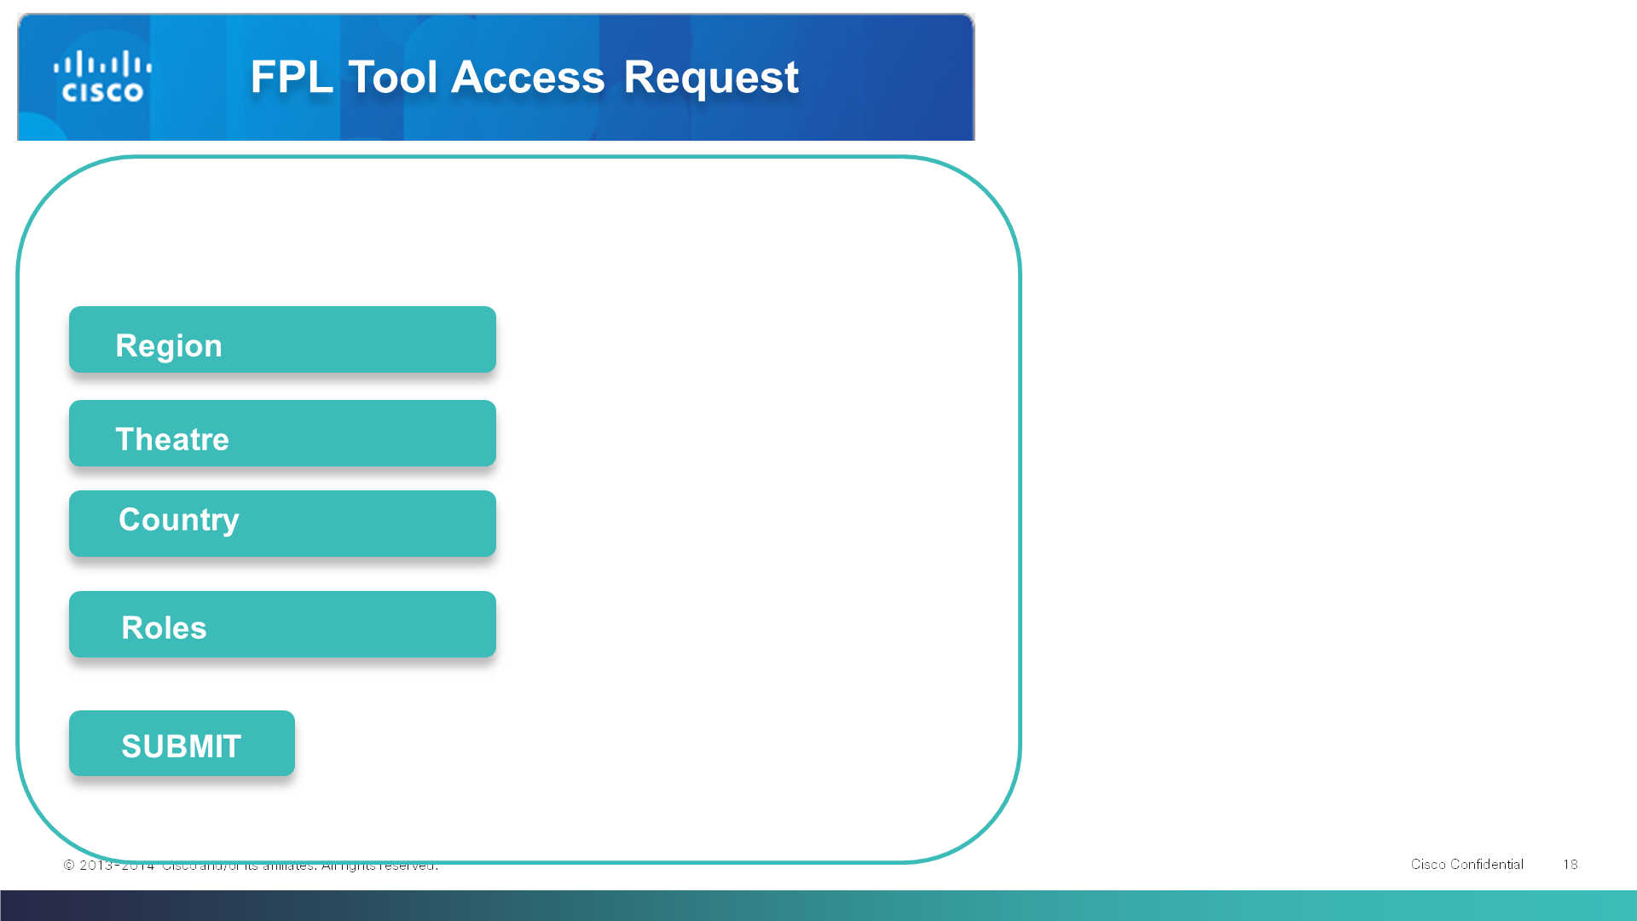

The user will submit the access request and email should be sent to the super admin with the details captured in the form. Super admin will login to the admin module and approve or reject the access. Super admin can also edit the Territory which the user is eligible for the access. Whenever the user request is approved or rejected an email should be sent to the users with the appropriate action.

Email Content

System email ID – mail will be sent out to super admin.

User ID:

Region:

Theatre:

Country:

Role:

The above mentioned user have requested for the FPL Tool access.

Please login to admin module to grant the permission.

Email Content

System email ID – mail will be sent out to super admin.

Dear User ID,

You have been granted the access / denied the access   
for the FPL tool as per the request.

Please login to the URL to access the application.

## 4.2 ADMIN ROLES:

The following types of the admin roles have been identified.

* SUPER ADMIN
  + Grant access permissions to the users
  + User Feedback Alert is routed to for action

## 4.3 USER METRICS:

This will be generated from backend data source on request. This is manual operation.

The basic metrics about the usage of the tool adoption is required.

* User Last Login
* How many times the user have logged into the application in a month
* Country based usage metrics
* Top 5 Partner Search of the user

## 4.4 DATA MAINTENANCE:

The Partner profile data will have to be refreshed once in 6 months. Data maintenance will be an ongoing activity and will be performed from the backend by the IT Support team.

However, GTMu Revenue data will be updated quarterly.

# Business Process:

The main data sources to populate the data required for the application are

1. PDB Analytics (Partner Database Analysis Reports)

2. Partner Strategic team input

3. Potential GMTu ?

In PDB Analytics there are two types of reports to be generated namely Certification Type reports and Specialization Type Reports.

# About the Business Requirement Document:

This document is built to basically visualize the business requirements. All the screen snaps in this BRD should be only considered as reference. These are not UI of the supplication. All the data and graphs displayed in this document is just a mock up and not the real data for analysis.